LAB 20.1
Ch .Tejaswi
2303A51944
B27

Task 1 – Input Validation Check PROMPT:
generate a simple username and password login program to review whether input sanitation and validation are implemented also suggest secure improvements CODE:
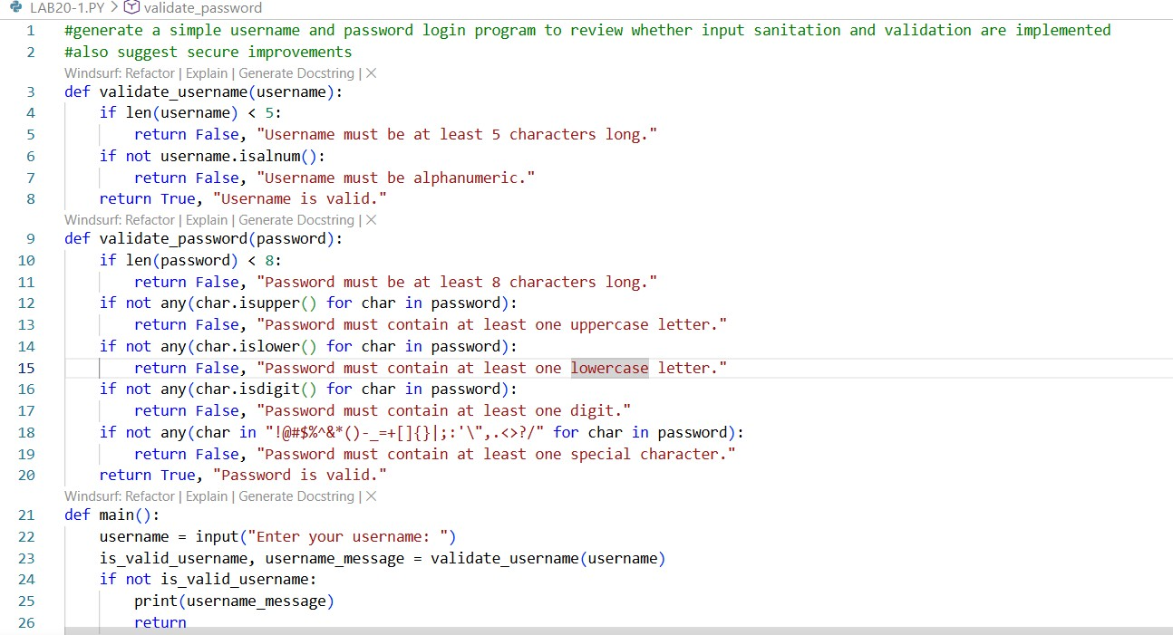
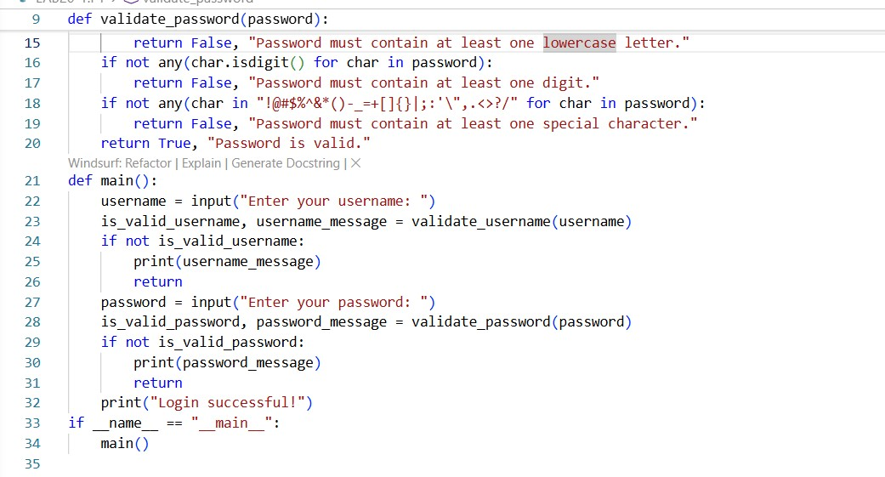
OUTPUT:
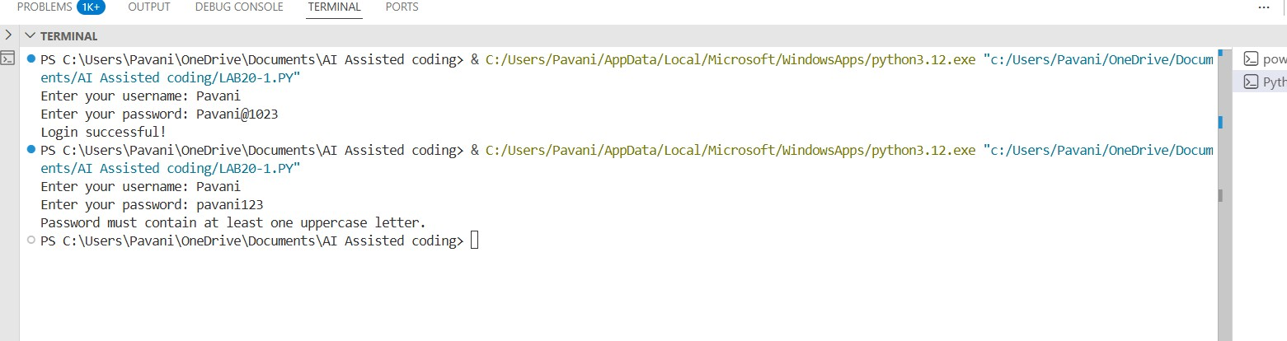
EXPLANATION:
- The program verifies that the username and password meet basic validation rules before allowing access.
- It ensures the username is long enough and contains only valid characters.
- It enforces a strong password by requiring a mix of letters, numbers, and special symbols.
- If any input is invalid, the login is stopped to maintain security

Task 2 – SQL Injection Prevention PROMPT:
generate a python script using sqlite/mysql to fetch user details and identify if the code is vulnerable to sql injection and refactor using parameterized queries
CODE:
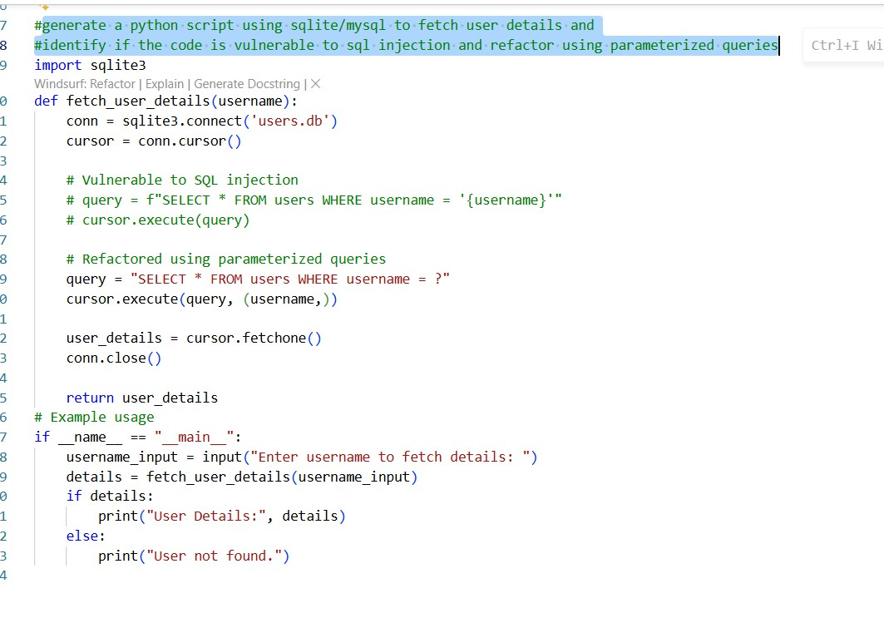

OUTPUT:
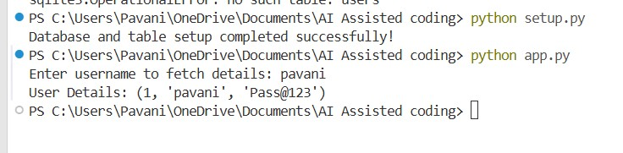

EXPLANATION:
- The setup file creates a database and a users table to store login data.
- It inserts a sample user so the program can retrieve data for testing.
- The main program takes a username as input and searches it in the database.
- It uses a secure query method to prevent SQL injection and ensure safe data access.

Task 3 – Cross-Site Scripting (XSS) Check PROMPT:
generate a feedback form with javascript based output and test whether untrusted inputs are directly rendered without escaping and implement secure measures eg. escaping html entities using csp
CODE:
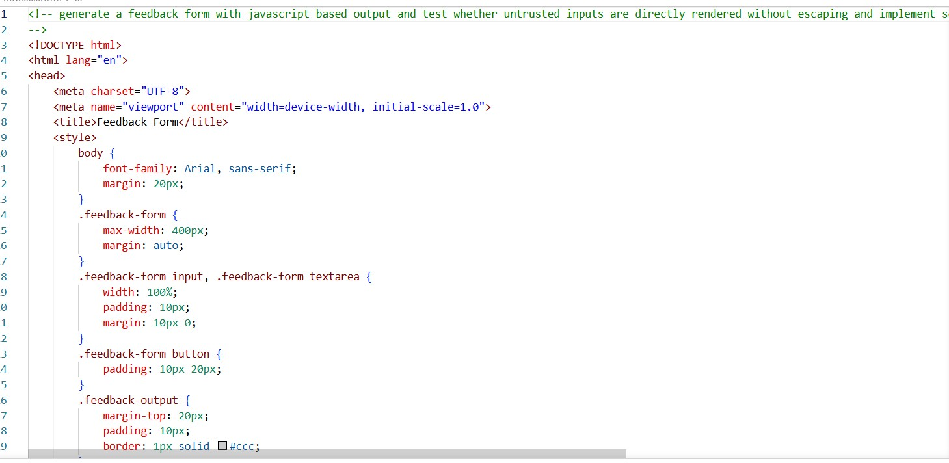
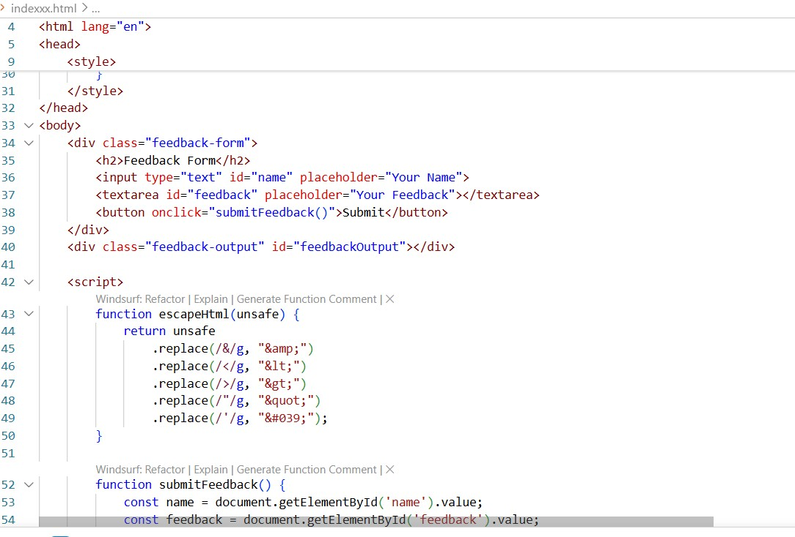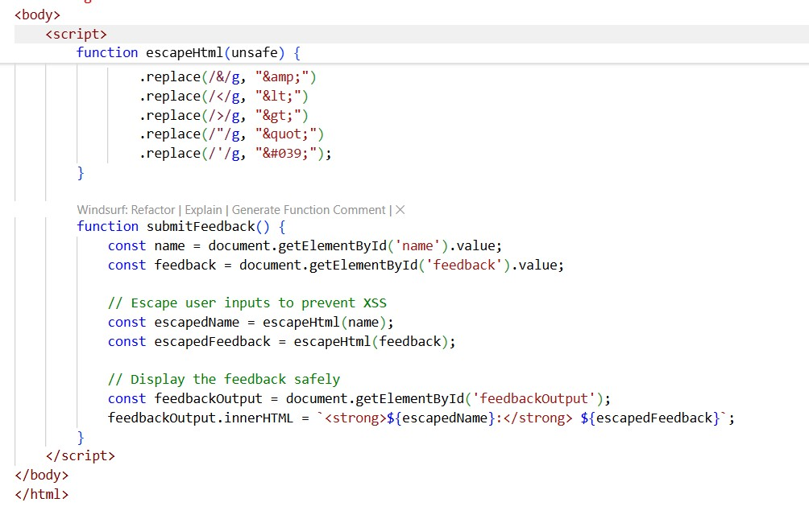

OUTPUT:
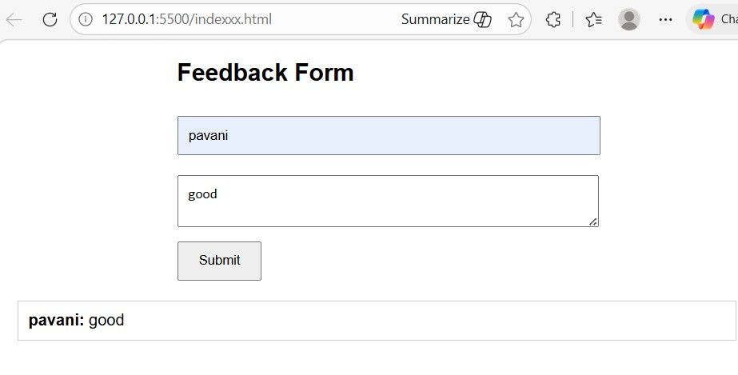
EXPLANATION:
- The program collects user feedback through a simple HTML form with name and message fields.
- It uses JavaScript to display the entered data dynamically on the page after submission.
- To prevent security issues like XSS, user inputs are escaped using a function before rendering.
- This ensures untrusted input is safely displayed without executing harmful scripts

Task 4 – Real-Time Application: Security Audit of AI-Generated Code
PROMPT:
select the code snippet eg login form and perform a security audit to detect possible vulnerabilities and suggest secure coding practices to fix issues and compare insecure vs secure versions side by side

CODE:
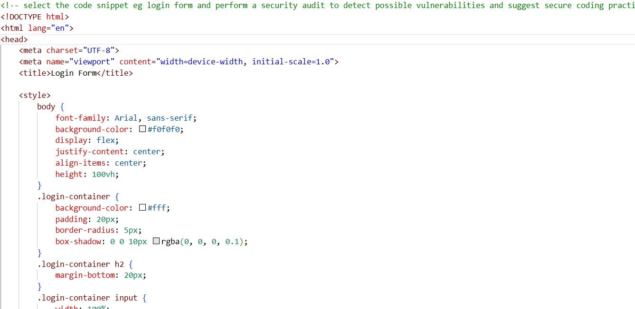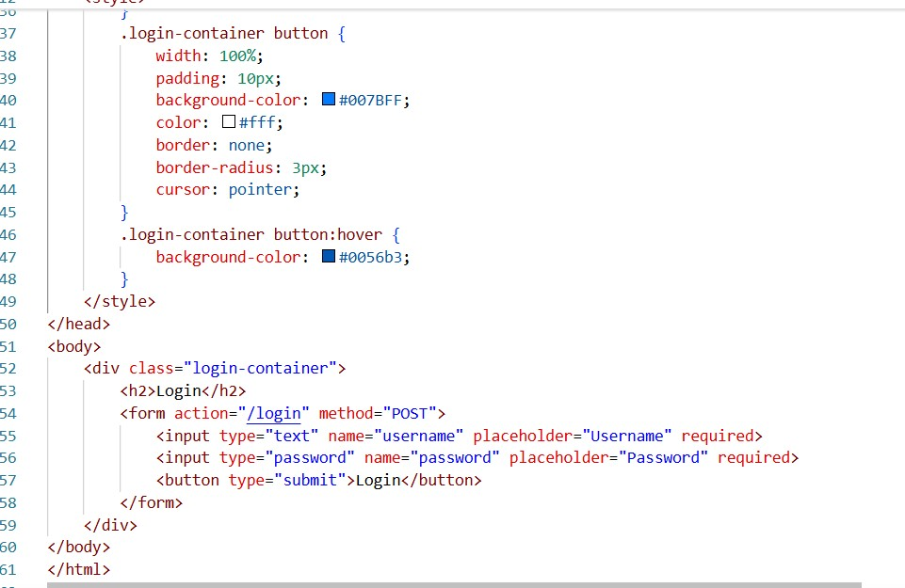

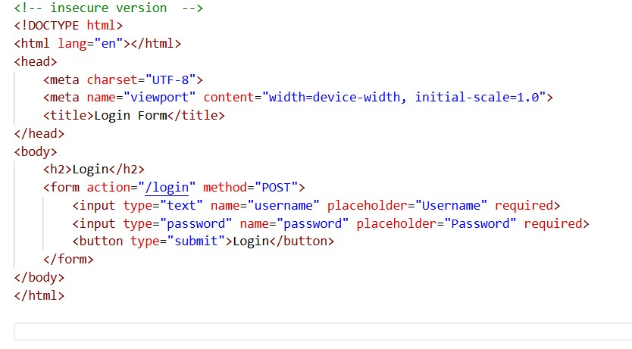

OUTPUT:

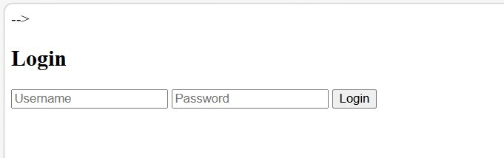
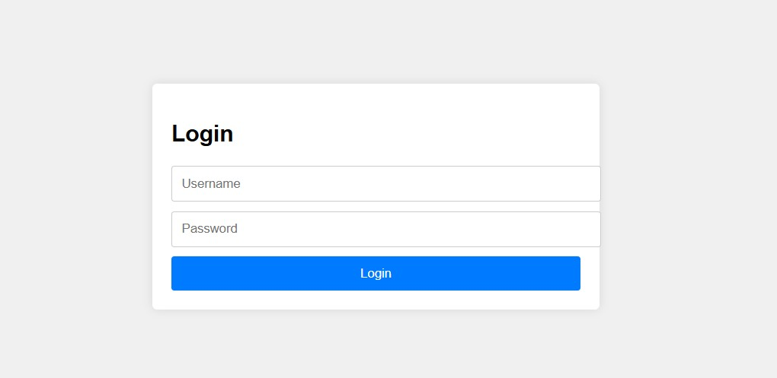
EXPLANATION
- The task shows both an insecure and a secure version of a basic login form in HTML.
- The insecure version simply takes input without any protection, which can lead to security risks.
- The secure version represents a safer approach, where such forms are expected to be combined with validation and backend security measures.
- It highlights the importance of handling user input carefully to prevent issues like data misuse or attacks.

Task 5 – Insecure Data Serialization Check PROMPT:
generate a script using pickle.load() and explain why untrusted pickle data is dangerous and replace with safer formats like json

CODE:
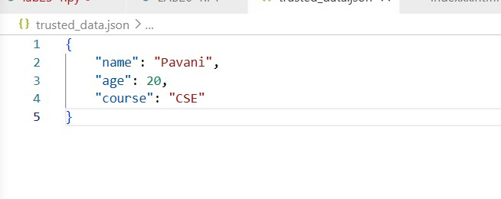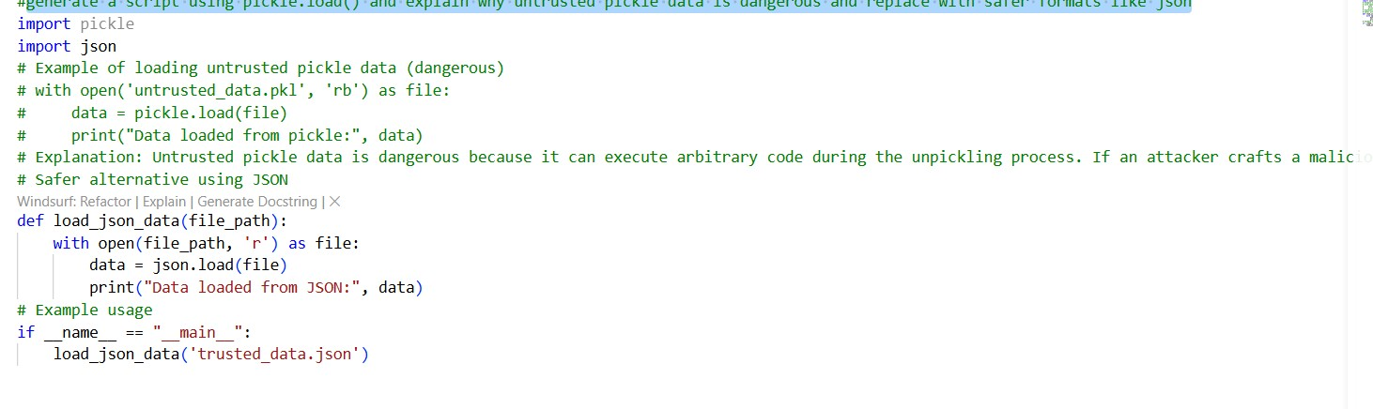

OUTPUT:
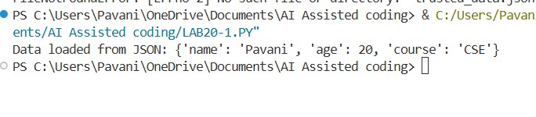
EXPLANATION:
- The program reads data from a JSON file using Python’s json module.
- It opens the file in read mode and loads the content into a Python object.
- The loaded data is then printed to verify the file contents.
- It demonstrates safe handling of trusted input files for data processing.

